Verify login with invalid data

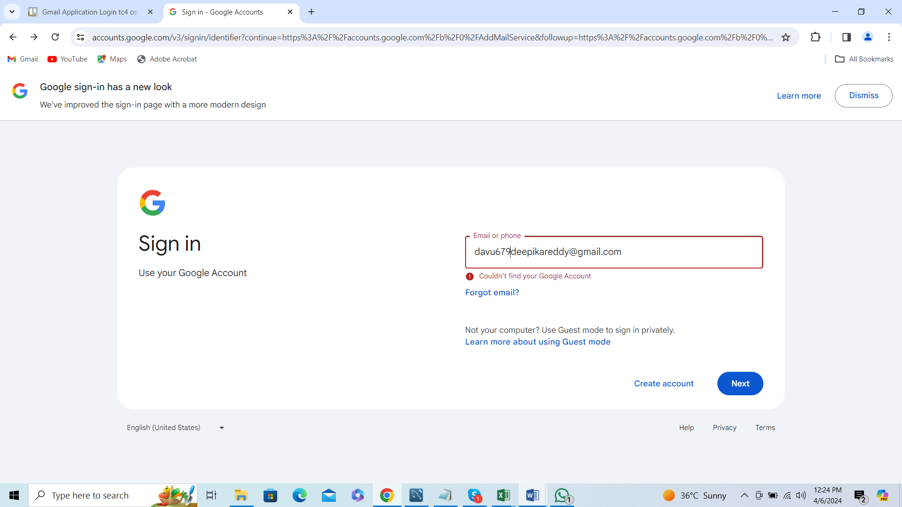

Error message is displayed